Join my team in the

by giving a gift that will help
one more family achieve stability
and security through owning a home that
we have made affordable and attainable.

Our page: justgiving.com/fundraising/replacethistext

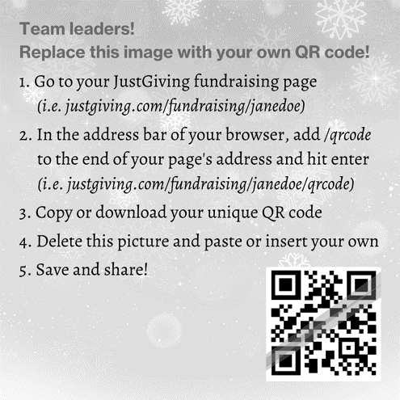
Scan me with your smartphone!
Join my team in the

by giving a gift that will help
one more family achieve stability
and security through owning a home that
we have made affordable and attainable.

Our page: justgiving.com/fundraising/replacethistext

Scan me with your smartphone!

